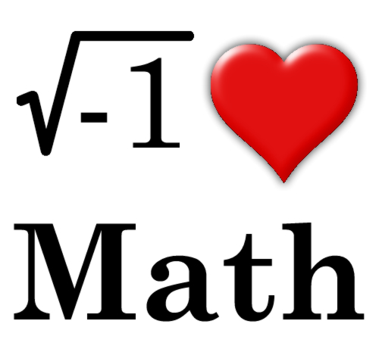

Math 9/10 Course Outline
Richmond Secondary School 2020-2021
Ms. Hom (Hayashi) Room 213
lhayashi@sd38.bc.ca
www.rssmath.wixsite.com/math

Welcome to Math 9/10! It’s going to be an amazing year!

Big Ideas:

- Algebra allows us to generalize relationships through abstract thinking.
- The meanings of, and connections between, each operation extend to powers and polynomials.
- Constant rate of change is an essential attribute of linear relations and has meaning in different representations and contexts.
- Trigonometry involves using proportional reasoning to solve indirect measurement problems.
- Representing and analyzing situations allows is to notice and wonder about relationships.

Further details on the new mathematics curriculum can be found at https://curriculum.gov.bc.ca/curriculum/mathematics/10/courses

Workbook: Theory and Problems for Foundations of Mathematics & Pre-Calculus 10,
3rd Edition, Mickelson (2018).

Required Supplies:

- scientific calculator (TI-83/TI-84 graphing calculator is optional)
- writing supplies, ruler, lined, and graph paper
- binder, dividers, workbook, and agenda

Evaluation and Assessment:

Homework, In-class Assignments, and Projects 10%
Quizzes 20%
Tests 70%

Term 1 20% Term 2 30% Term 3 30%

*Midterm before Winter Break. *Final Exam in June is worth 20% of your Final School Mark.

Class Expectations

1. Please refer to Classroom Expectations Sheet or Class Policies online.
2. Attendance: Parents will be informed of habitual lates and unexcused absences.
Lates: Please arrive to class on time. Obtain a late slip from the office if you are late.
Absences: Please have your parent/guardian call the school or provide a note to the office
explaining the reason for your absence. It is your responsibility to make up all missed
work. Homework from missed classes will be due the same date as the rest of the class.
3. Electronic devices: Please do not use cell phones, headphones, or other devices in class.

Communication

I will be available in the morning after 8 am, during most lunch hours, and Tuesday/Thursday after school in my classroom during Math help. Appointments can also be made. Parents/Guardians – Please provide any information about your child that may help me better support them in their learning this year by contacting me at lhayashi@sd38.bc.ca.

______________________________ _______________________________
Student Signature Parent/Guardian Signature

FAPC 10 Topic Outline:

Unit 1 – Real Numbers (Ch. 1 Mickelson)

- Number Systems
- GCF and LCM
- Squares and Square Roots
- Rational and Irrational Numbers
- Exponential Notation
- Irrational Numbers

Unit 2 – Polynomials (Ch. 2 Mickelson)

- Classifying Polynomials
- Multiplying Polynomials
- Removing Common Factors
- Factoring x² + bx + c
- Factoring ax² + bx + c
- Special Factors

Unit 3 – Relations and Functions (Ch. 3 Mickelson)

- Relations
- Functions
- Linear Equations
- Non-Linear Equations
- Graphing with a Calculator

Unit 4 – Linear Functions (Ch. 4 Mickelson)

- Slope
- Rate of Change
- Graphing Linear Functions
- Parallel and Perpendicular Lines
- Applications of Linear Relations

Unit 5 – Linear Equations (Ch. 5 Mickelson)

- Different Forms of Linear Equations
- Special Cases of Linear Equations
- Equations of Parallel and Perpendicular Lines
- Linear Applications and Modelling
- Function Notation

Unit 6 – Solving Linear Equations (Ch. 6 Mickelson)

- Solving Linear Systems by Graphically
- Solving Linear Systems by Addition
- Solving Linear Systems by Substitution
- Problem Solving with Two Variables
- Arithmetic Sequence
- Arithmetic Series
Unit 8 – Finance (Ch. 7 Mickelson)
- Simple and Compound Interest
- Gross and Net Pay
- Tax Rates
- Net Income

Unit 7 – Trigonometry (Ch. 8 Mickelson)

- Sine, Cosine and Tangent for Right Triangles
- Special Angles
- Applications of Trigonometry
*This is a tentative course outline and may be subjected to change*

