School & Classroom Policies 2020-21
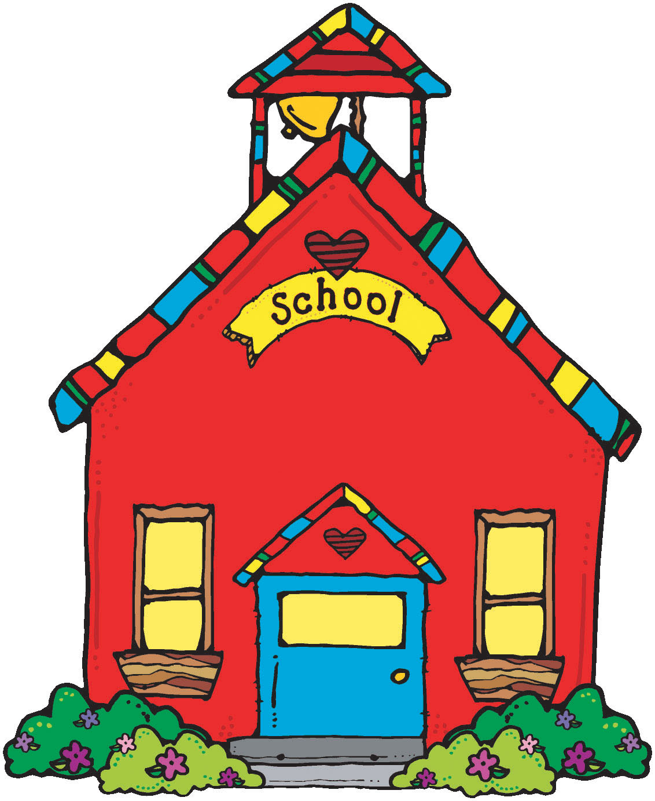

1. Please arrive to school no earlier than 10 minutes than your scheduled starting time. Masks are required for the hallways.

Grade 10, 11, and 12 9:15 am Grade 8 and 9 9:30 am

If you arrive to school more than an hour after the start time, please report to the office.

*If at any time you do not feel well, tell your teacher and proceed to the office for signing out and pick-up.
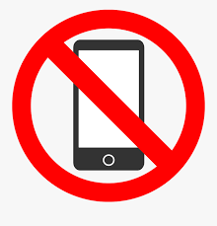
2. Please turn off your electronic devices. Cell phones can be put on silent/vibrate mode. No music players or headphones.

3. With permission, you may leave the classroom to use the washrooms. Wear a mask and sanitize your hands when re-entering the classroom. Do not wander in the hallways or other classrooms.

4. If permitted, food and drinks may be eaten in class. No sharing please. Throw all garbage, compost, and recyclables in the appropriate bins.
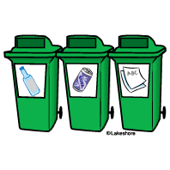

5. At the end of class, sanitize your desks, chairs, supplies, and your hands.

6. If you are absent for a class, email your teacher to obtain missing work.

7. If you know the date of a future absence (medical appointment, field trip, etc.), please inform your teacher. If you are going to absent for more than a week, please pick up an extended absence form from the office.

